

SIMATS ENGINEERING

Saveetha Institute of Medical and Technical Sciences Chennai- 602105

Student Name: Anu. R Reg. No: 192324278
Course Code: DSA0613 Slot: A
Course Name: Data Handling and Visualization for Data Analytics Course Faculty: Dr. Kumaragurubaran T & Dr. Senthilvadivu S
Project Title: Geospatial Visualization of Population Density for Regional Pattern and Trend Analysis
Module Photographs:
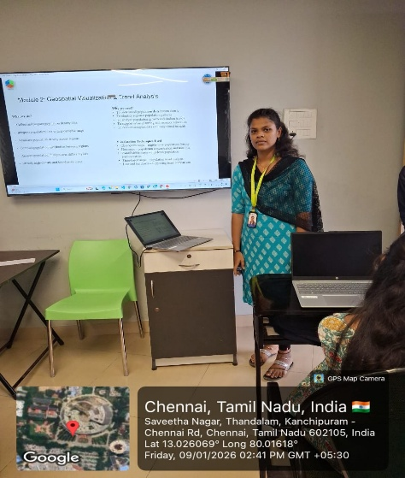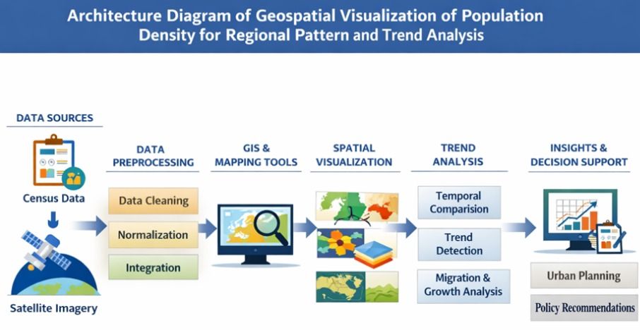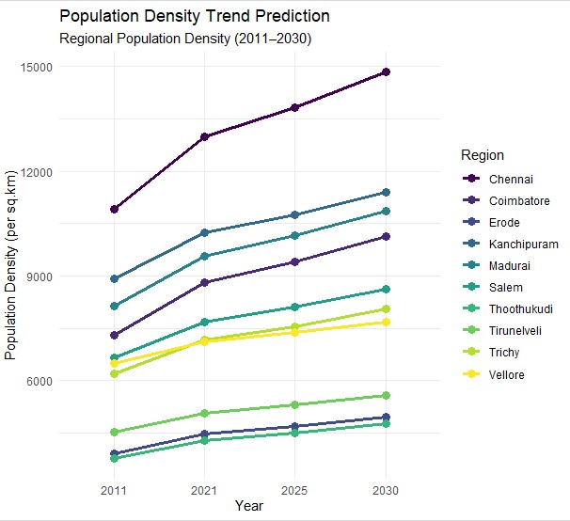
Project Description: Geospatial Population Density Trend Prediction
This module focuses on analyzing and predicting population density trends by integrating spatial data with statistical and machine learning techniques. Geospatial population density refers to the distribution of people across geographic regions and how this distribution changes over time. In this module, spatial datasets such as census data, satellite imagery, and administrative boundary data are used to understand regional population patterns. The process begins with data collection and preprocessing, including geocoding, spatial aggregation, and normalization of population values per unit area. Geographic Information Systems (GIS) tools and spatial libraries are applied to visualize population density using thematic maps such as choropleth and heat maps. Temporal analysis is then performed to identify growth, decline, or migration trends across different regions. Predictive modeling techniques, including regression models, clustering, and time-series forecasting, are employed to estimate future population density patterns. These models help identify high-growth zones, urban expansion areas, and regions facing population decline. The outcomes of this module support urban planning, infrastructure development, and resource allocation.

Student Signature Guide Signature

